**Project Design Phase**

**Problem – Solution Fit Template**

|  |  |
| --- | --- |
| Date | 15 February 2025 |
| Team ID | TVIP2025TMID53284 |
| Project Name | Mern Stack |
| Maximum Marks | 2 Marks |

**Problem – Solution Fit Template:**

The Problem-Solution Fit simply means that you have found a problem with your customer and that the solution you have realized for it actually solves the customer’s problem. It helps entrepreneurs, marketers and corporate innovators identify behavioral patterns and recognize what would work and why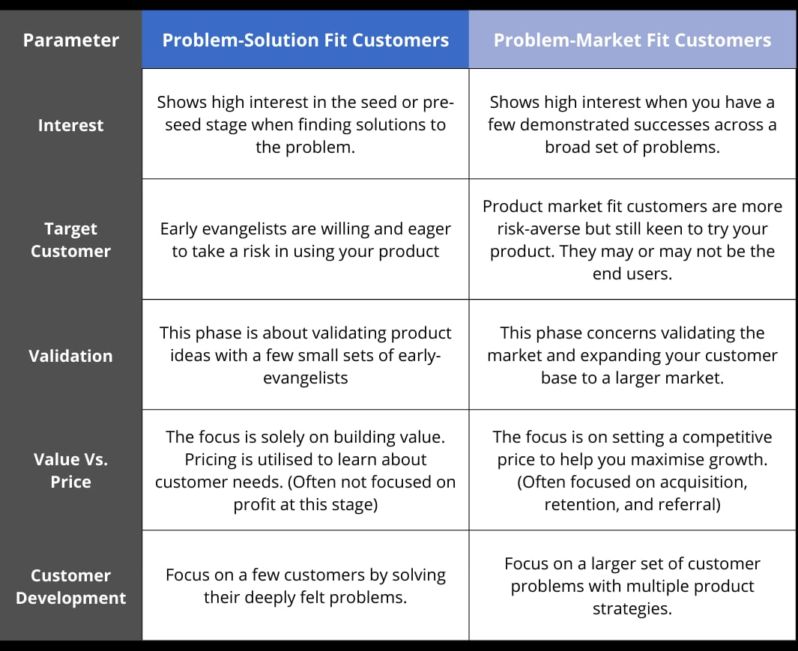

**Template:**

